**P1. Bayesian networks (50 points)**

You are given a Bayesian network structure, each consisting of 5 binary random variables A, B, C, D, E. Each variable corresponds to a gene, whose expression can be either “ON” or “OFF”.



**(A – 20 points)** In class, we covered the chain rule of probability for Bayes Nets, which allows us to estimate the joint probability over all the variables via product of conditional probabilities. For each of the following cases, calculate P(A,B,C,D,E) according to the dependencies specified and give the **minimum** number of parameters required to fully specify the distribution.

1. A,B,C,D,E are all mutually independent
2. A,B,C,D,E follow the dependency assumptions of network #1above

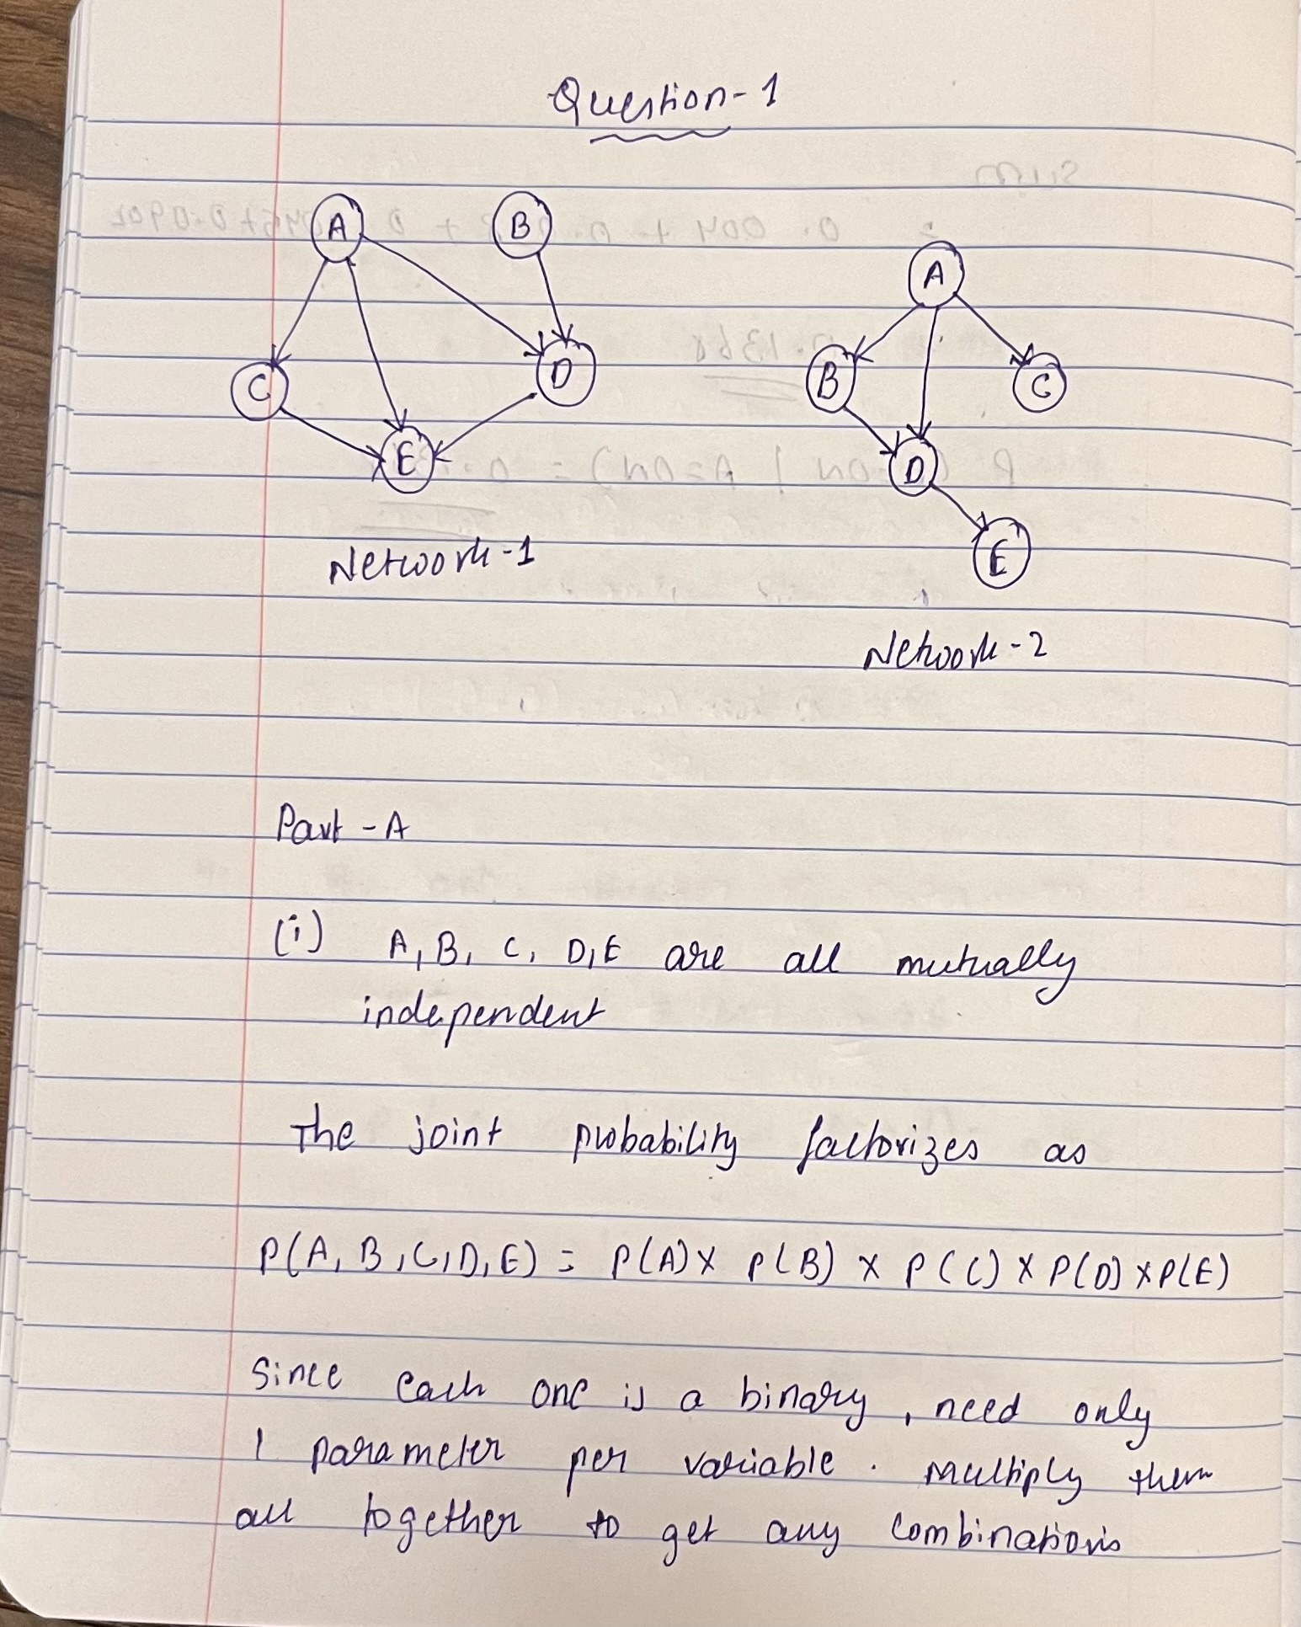

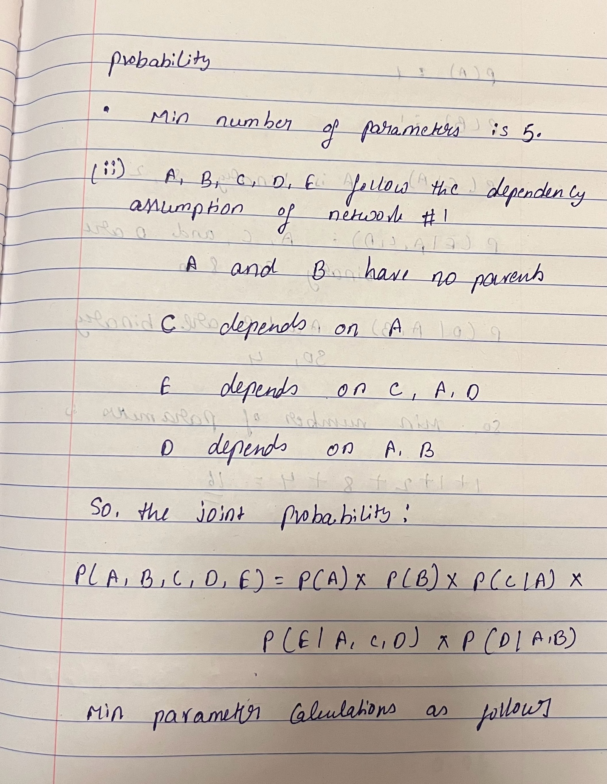

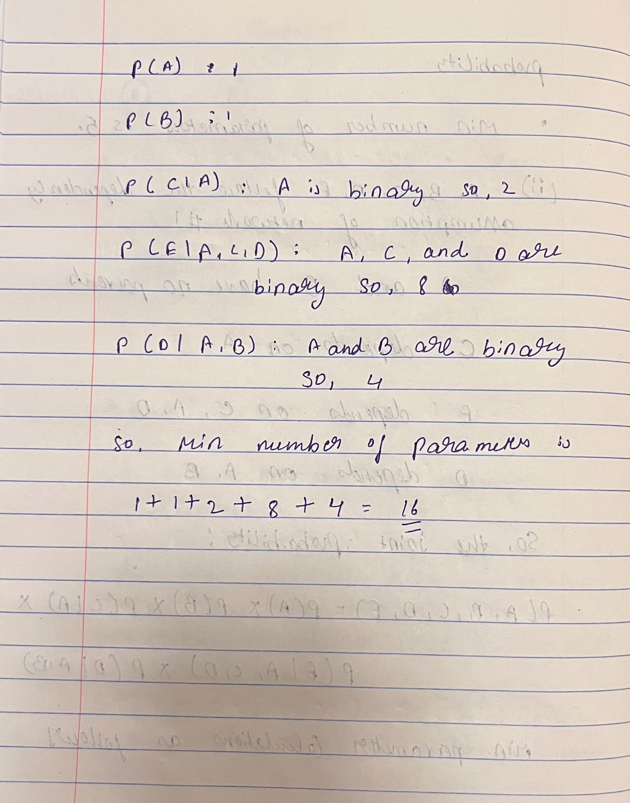

**(B-30 points)** Using **the network structure #2 in question A** and the probabilities given below, calculate the probability of the following:

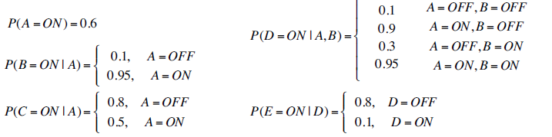

1. P(A=ON, B=ON, C=ON, D=ON, E=ON)
2. P(E = ON | A = ON)

**Hint**: Identify the ancestor subgraph first

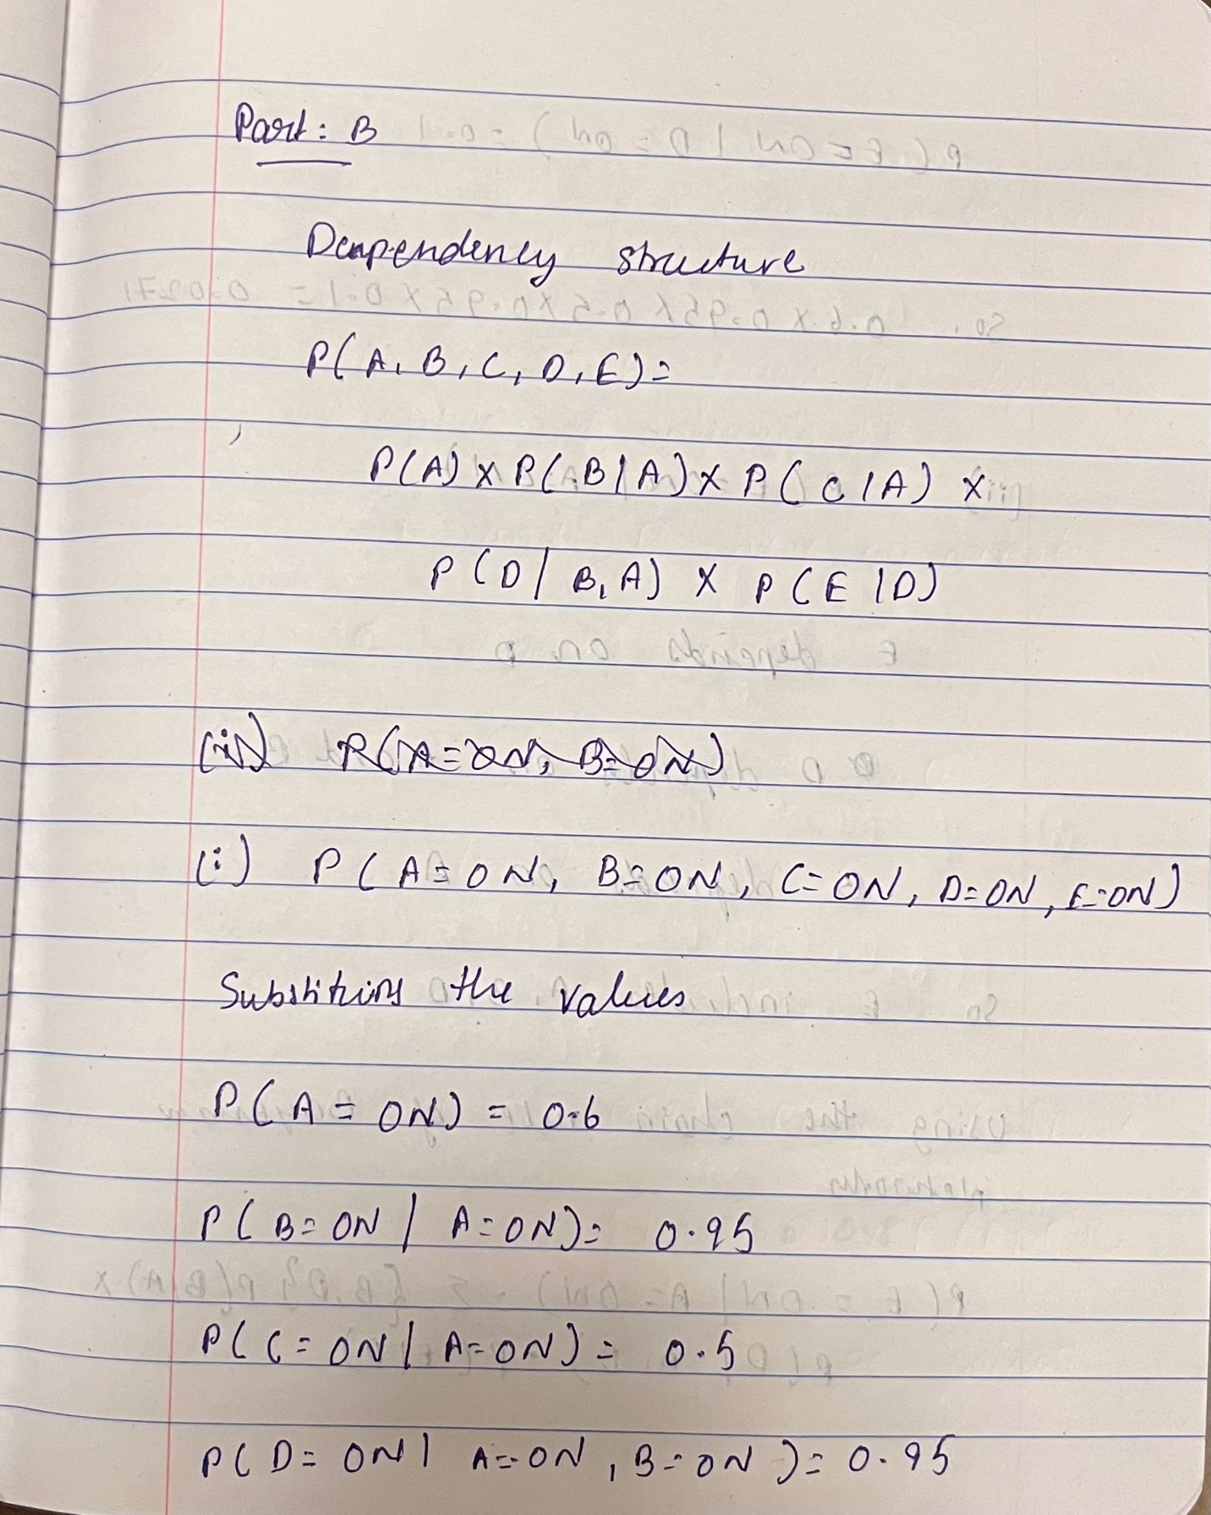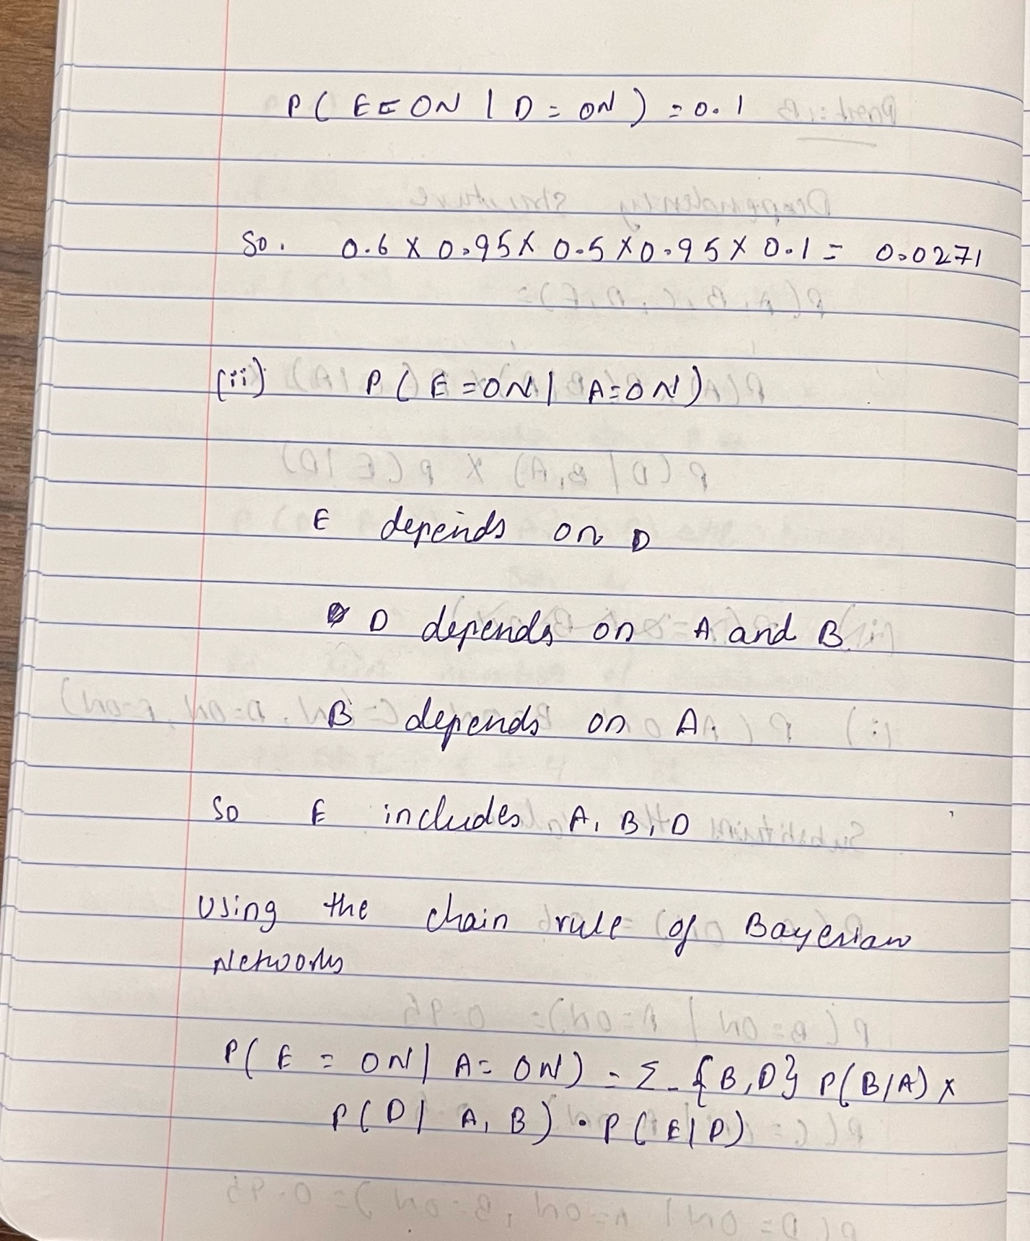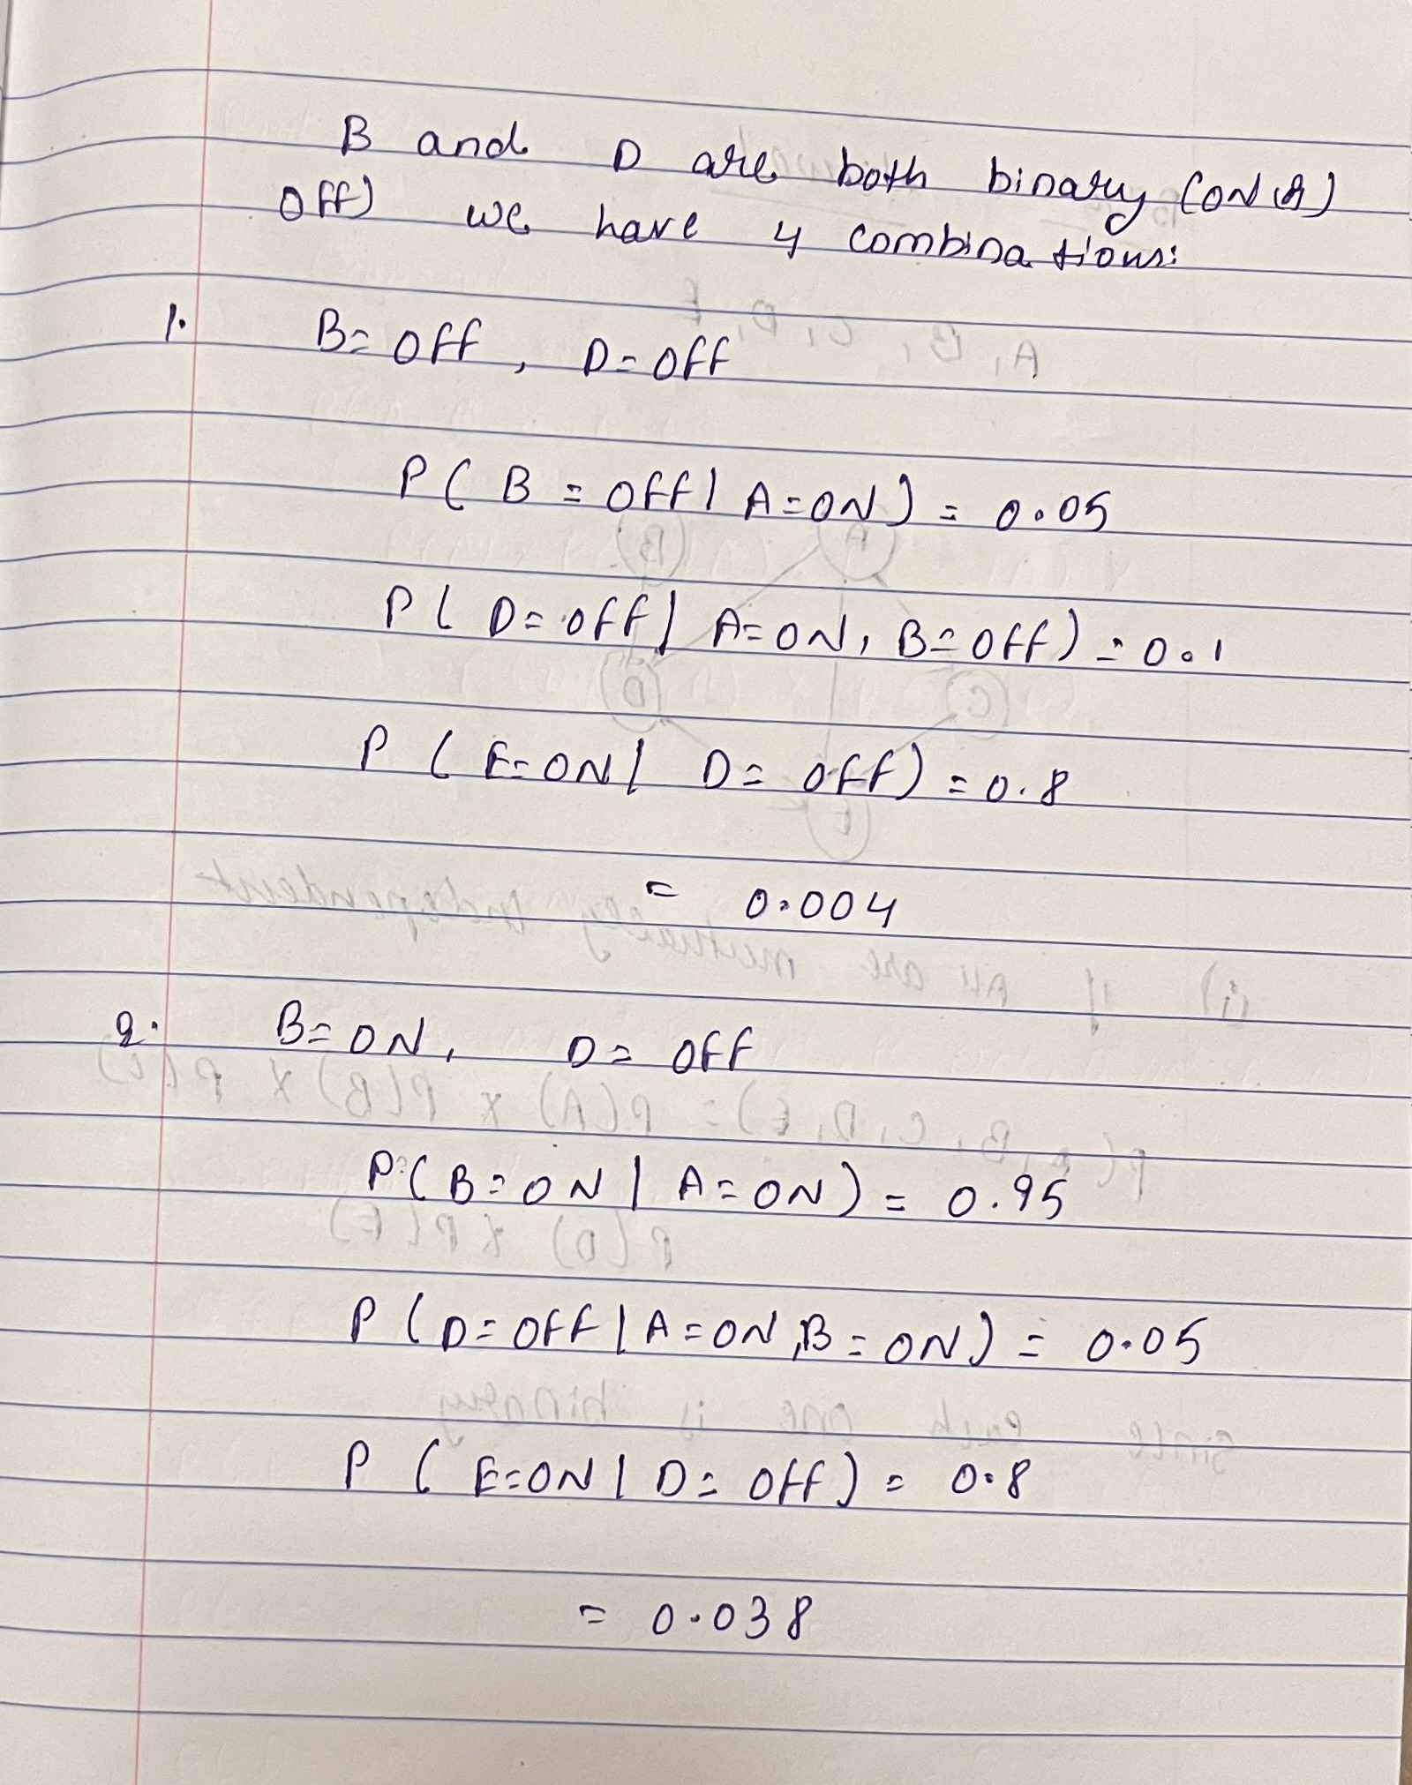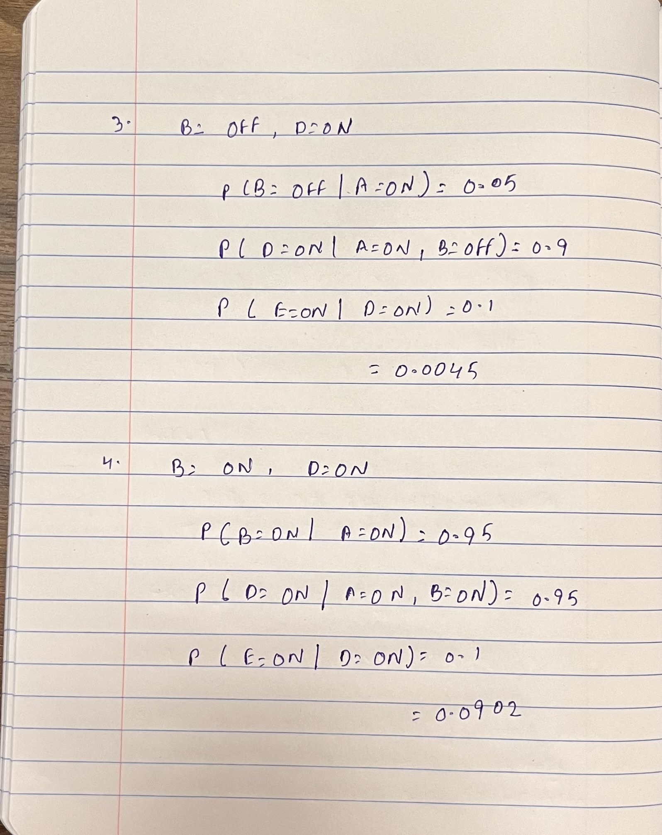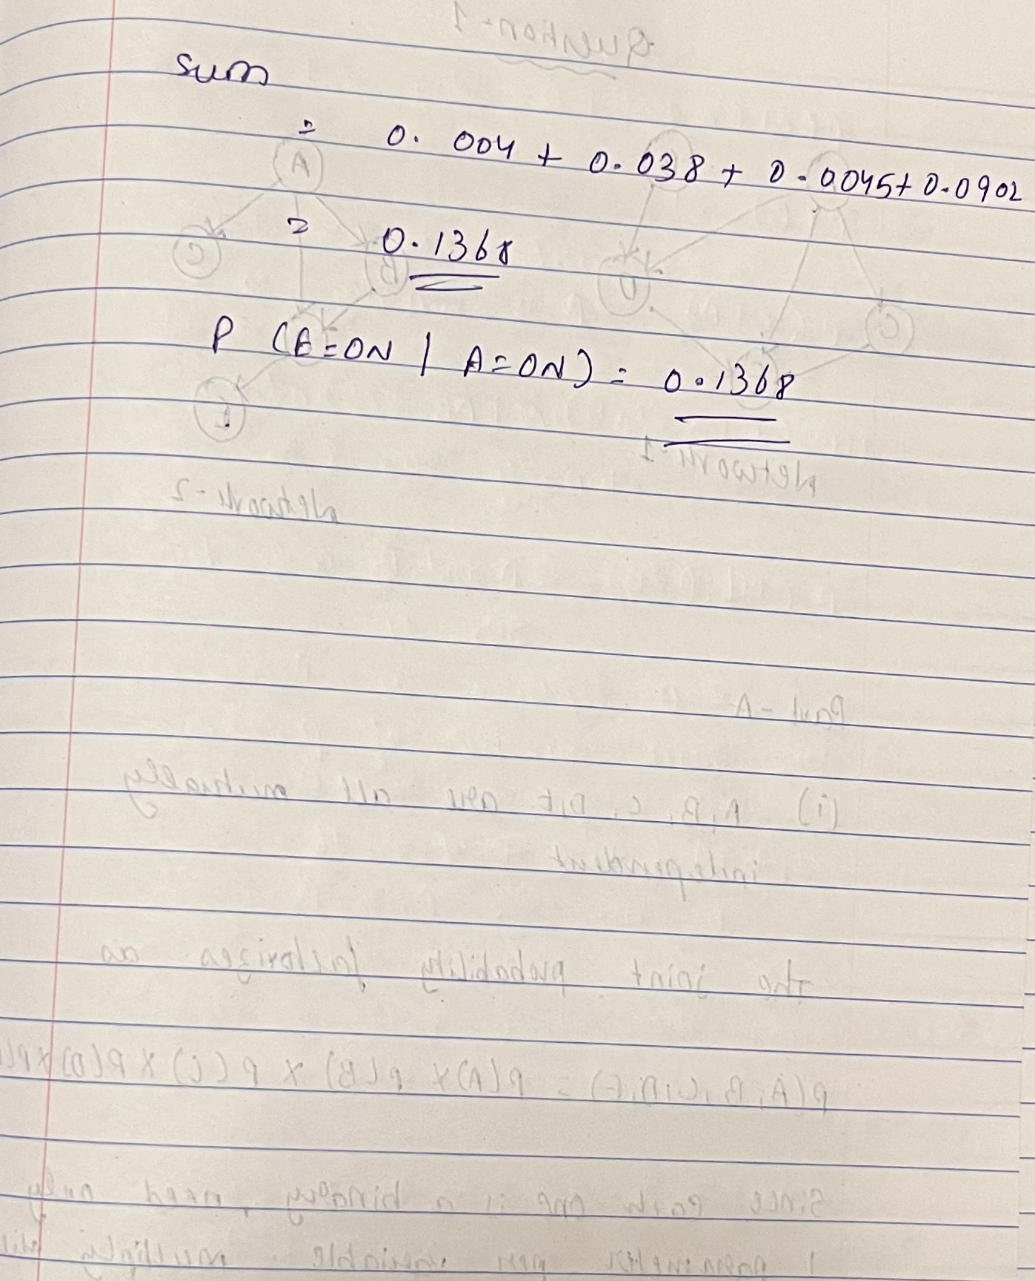

P2. WGCNA (**50 pts**)

Two data files were attached for this question: gene expression file “HW02_expression.csv” (genes in rows and samples in columns) and trait file “HW02_traits.csv” (samples as rows and traits as columns). First, remove samples that miss either expression data or trait data. Then follow section 2.1 to 3.1 in the link below and perform the following tasks. <https://deneflab.github.io/HNA_LNA_productivity/WGCNA_analysis.html>

1. Choose the soft-thresholding power (Provide figures showing the R2 and mean connectivity across different power).
2. Perform gene clustering using TOM-based dissimilarity.
3. Merge similar modules. Visualize the dendrogram and merged modules in different color, as shown in the end of section 2.1 in the link.
4. For each module, calculate its first eigengene and associate with the two traits in the “HW02_traits.csv” respectively.
5. For each trait, plot a heatmap to show the association between modules and trait, same as 3.1 in the link.

**Solution:** R Code file separately attached to the submission.

Question-1

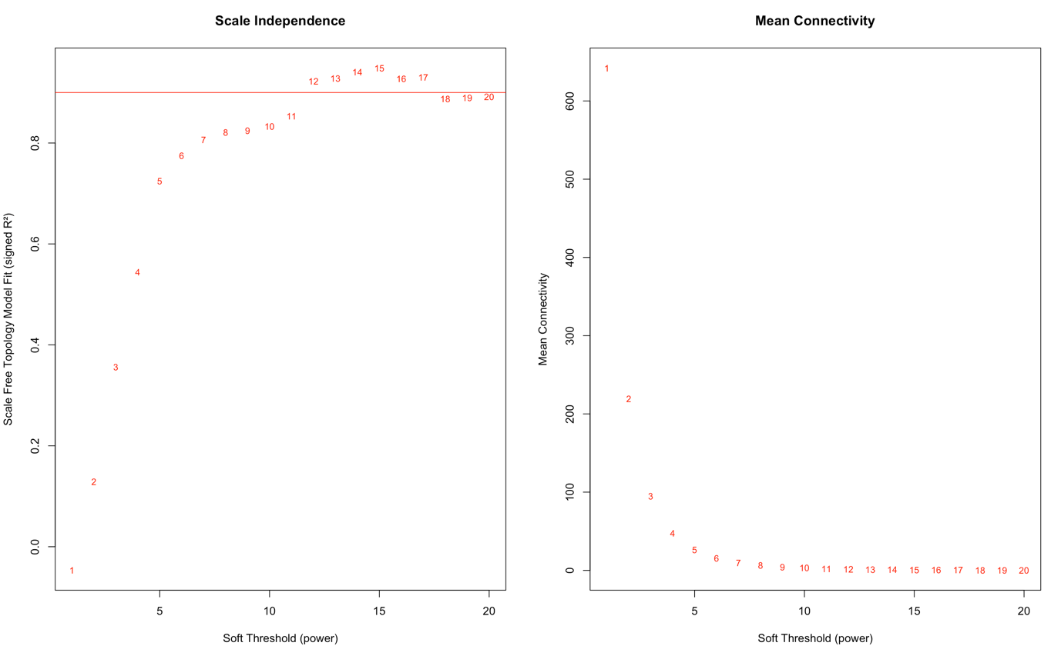

Question-2

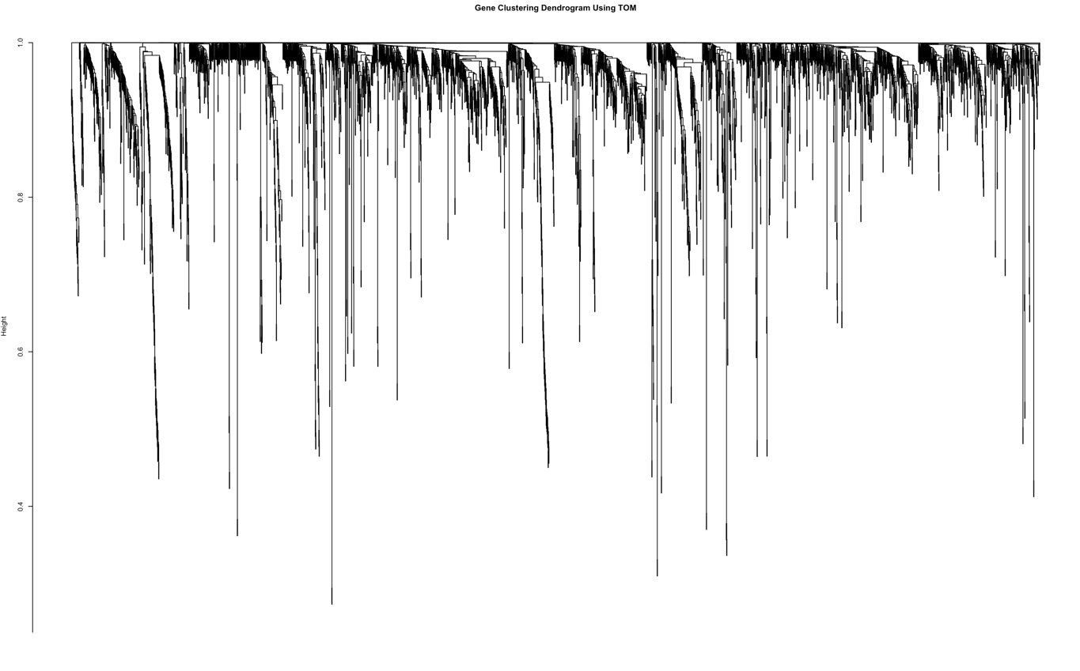

Question-3

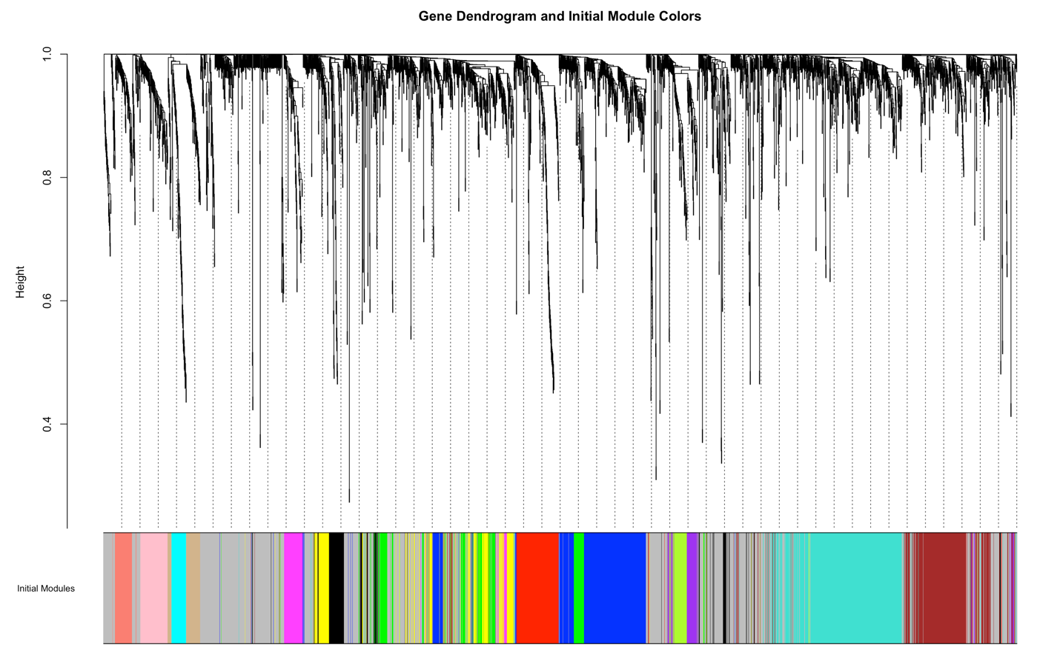

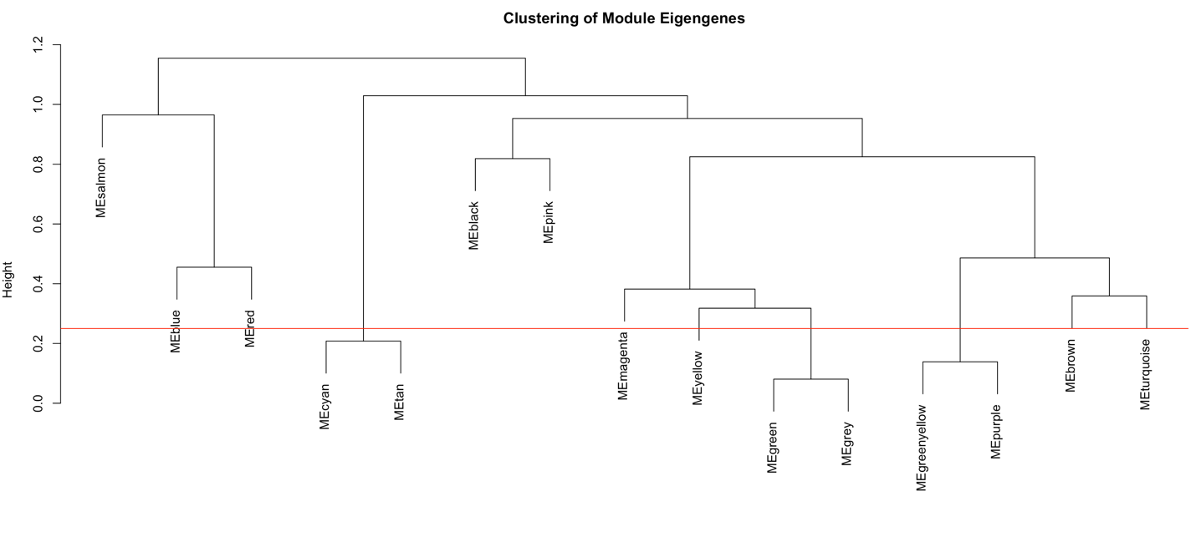

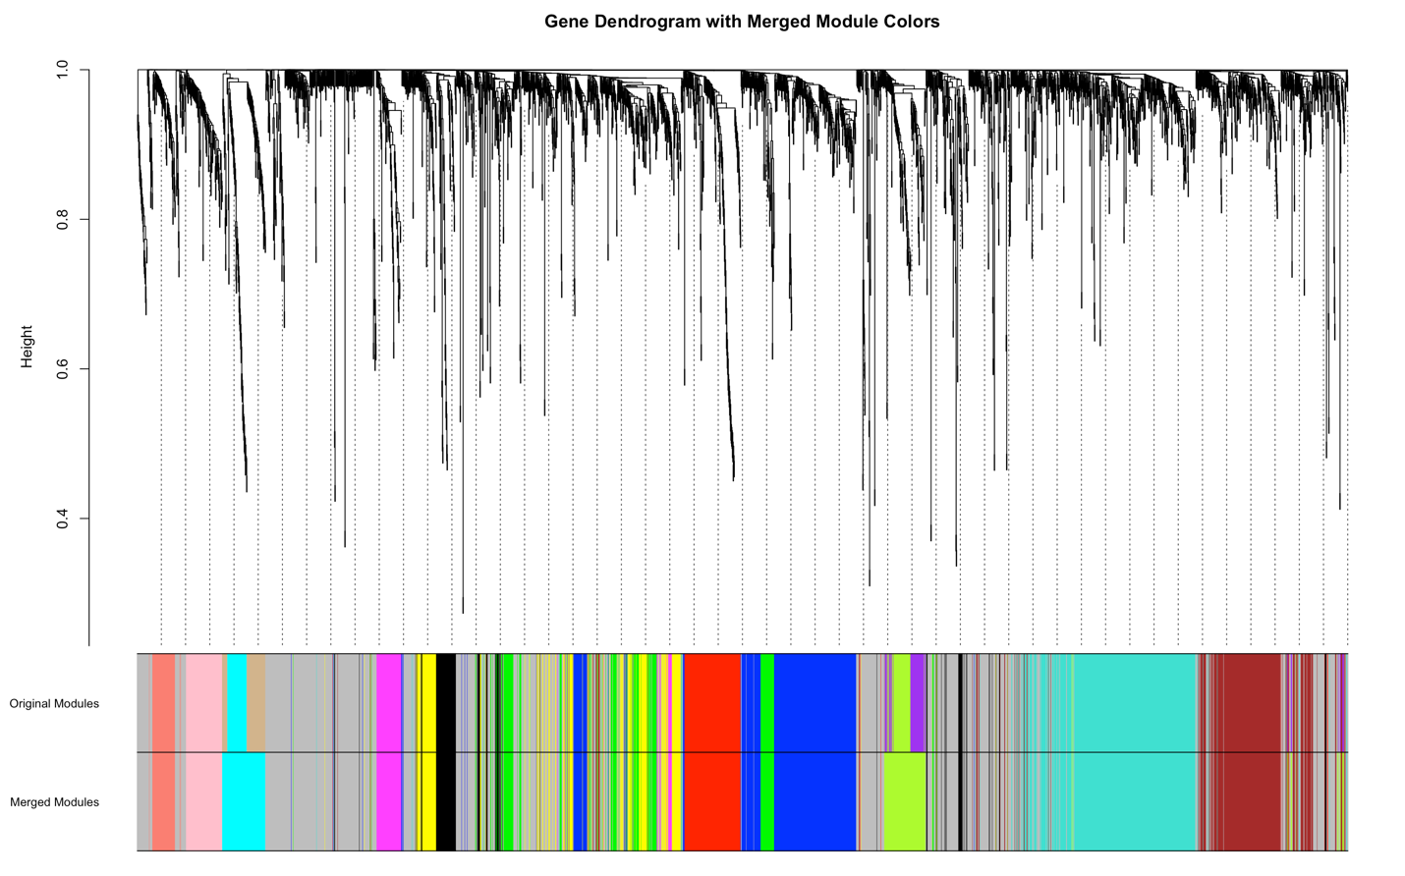

Question-4

Run the code file

Question-5

